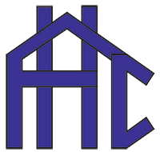 | FLINT HOUSING COMMISSION  AGENCY FACT SHEET │ CITY OF FLINT, MICHIGAN
HOUSING. OPPORTUNITY. COMMUNITY. │ Safe, decent & affordable housing since 1964, helping our community grow and our residents prosper.
602  Public Housing Units | 389  RAD Units | 1,100+  Housing Vouchers | $19M  Annual Budget | 79%  HUD-Funded | 60+  Years of Service

ABOUT FHC  Mission: We are committed to helping our community grow and our residents prosper by providing housing in pleasant communities at sensible rents.  The Flint Housing Commission (FHC) is a public housing authority created in 1964 that serves the City of Flint, providing safe, decent, and affordable housing to low- and moderate-income families while fostering pathways to economic independence.  A five-member Board of Commissioners, appointed by the Mayor of Flint, sets agency policy. The Chief Executive Officer, appointed by the Board, serves as and carries out that policy.  OWNED & OPERATED PORTFOLIO  Public Housing: 602 units — 5 developments + 68 scattered sites  RAD Communities: 389 units — 4 communities  Scattered-Site Program: 68 homes dispersed across Flint  Total Owned: 991 units across 9 communities  BEDROOM SIZE MIX  OUR GOAL  To improve the living conditions of the people who choose to reside with us — and to connect housing with opportunity, stability, and community. | VOUCHER & ASSISTANCE PROGRAMS  All voucher programs may be used to lease housing within Genesee County. VASH participants have the added option to use their voucher in St. Clair County.  RESIDENT SNAPSHOT  Avg. Annual Income — HCV: $18,165  Avg. Annual Income — Public Housing (LIPH): $12,000  BUDGET & FUNDING  $19 Million annual operating budget  79% HUD (federal) sources │ 21% resident rental income, state & local sources, and annual HUD modernization grants. | PROPERTY LOCATIONS ACROSS FLINT  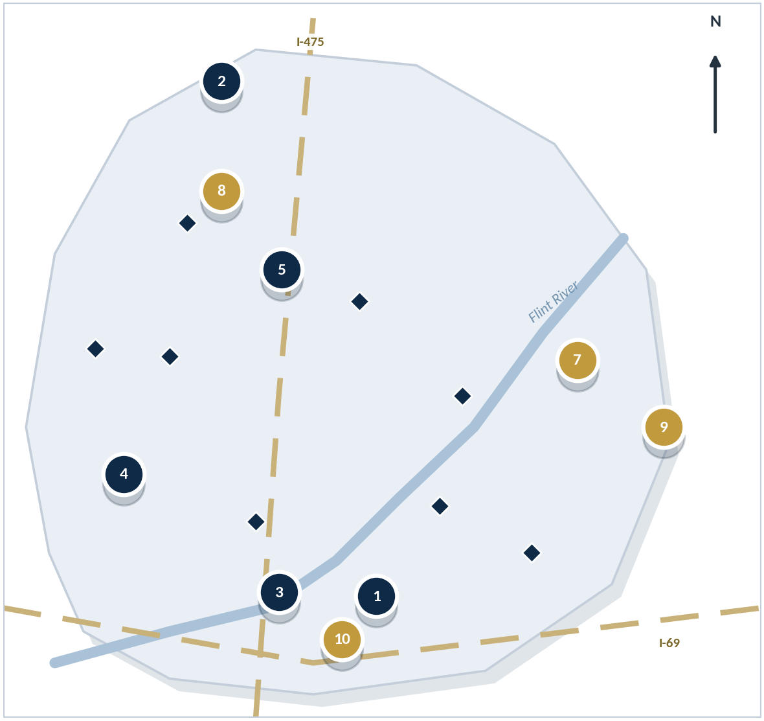  ● Public Housing ● RAD ♦ Scattered Sites  1. Richert Manor — 902 E Court St, Flint, MI (128 family members)  2. River Park Townhomes — 7002 Pemberton Dr, Flint, MI (394 family members)  3. Garland Chase Apartments — 820-906 Garland St, Flint, MI (44 family members)  4. Kenneth M. Simmons Square — 2101 Stedron St, Flint, MI (160 family members)  5. Forest Park Apartments — 4060 Martin Luther King Ave, Flint, MI (19 family members)  6. Scattered-Site Program — 68 homes citywide, Flint, MI  7. Mince Manor Apartments — 3800 Richfield Rd, Flint, MI  8. Aldridge Place Townhomes — 5730 Edgar Holt Dr, Flint, MI  9. Centerview Apartments — 2001 N Center Rd, Flint, MI  10. Howard Estates — 1928 Howard Ave, Flint, MI
  Efficiency | 1 BR | 2 BR | 3 BR | 4 BR
  30 | 320 | 55 | 86 | 42
  Program | Served | Voucher Service Area
  Housing Choice Vouchers (HCV) | 1,589 individuals served | Genesee County
  Veterans Affairs Supportive Housing (VASH) | 58 veterans | Genesee & St. Clair Counties
  Project-Based Vouchers (PBV) | 24 family members | Genesee County
  Mainstream Vouchers | 16 family members | Genesee County
  Fostering Youth Initiative | 2 family members | Genesee County
  Low Income Public Housing (LIPH) | 799 family members | Genesee County
  HCV Homeownership Program | First-time homebuyers | Genesee County

FLINT HOUSING COMMISSION
Safe, decent & affordable housing │ City of Flint, Michigan │ Equal Housing Opportunity
3820 Richfield Rd, Flint, MI 48506 │ 810-736-3050 │ www.flinthc.org │ Office Hours: 9:00 AM – 4:00 PM

